**Foxfire Activewear**

**UPDATED Size Charts April 2025**

All size charts are measured in inches. Please include your measurements when ordering if you’d like to check your sizing. Blended sizes can be made but will render your order non-returnable.

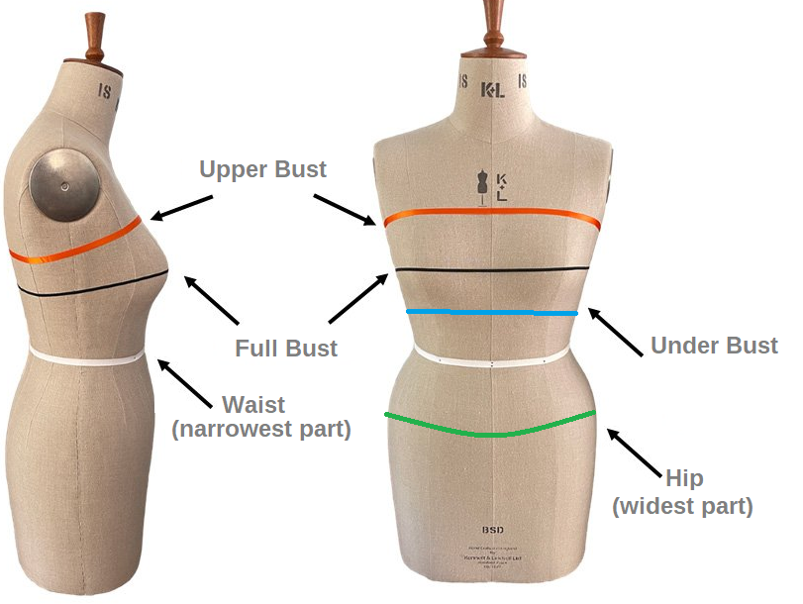

**Banded Booty Shorts & Super Booty Shorts.**

Available in Low, Mid and High Waisted Styles. There are stretchy bands on the waist and legs of these items which give it an extra secure fit! Garters can be added onto this style and are attached only at the crotch area. Scrunch Butt can also be added onto this style.

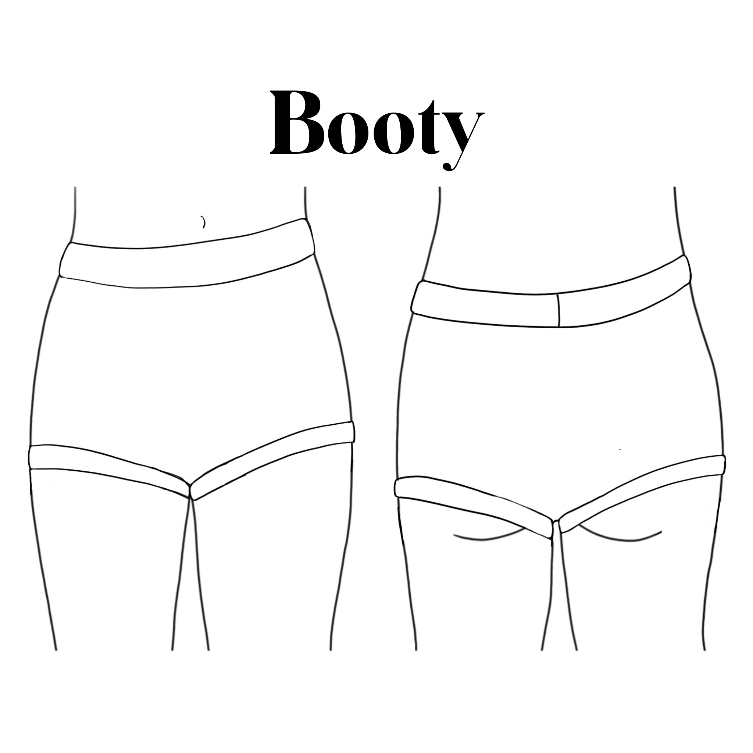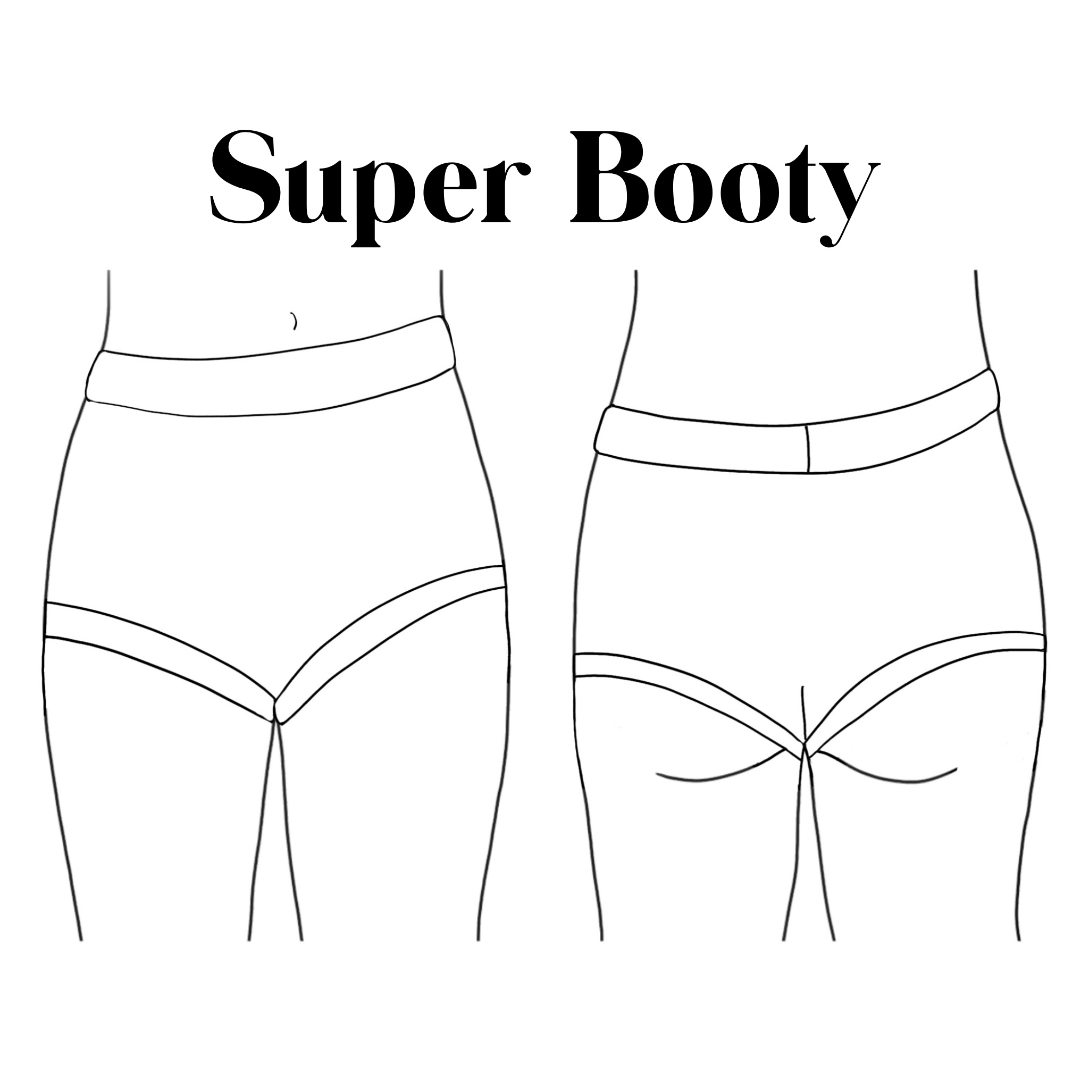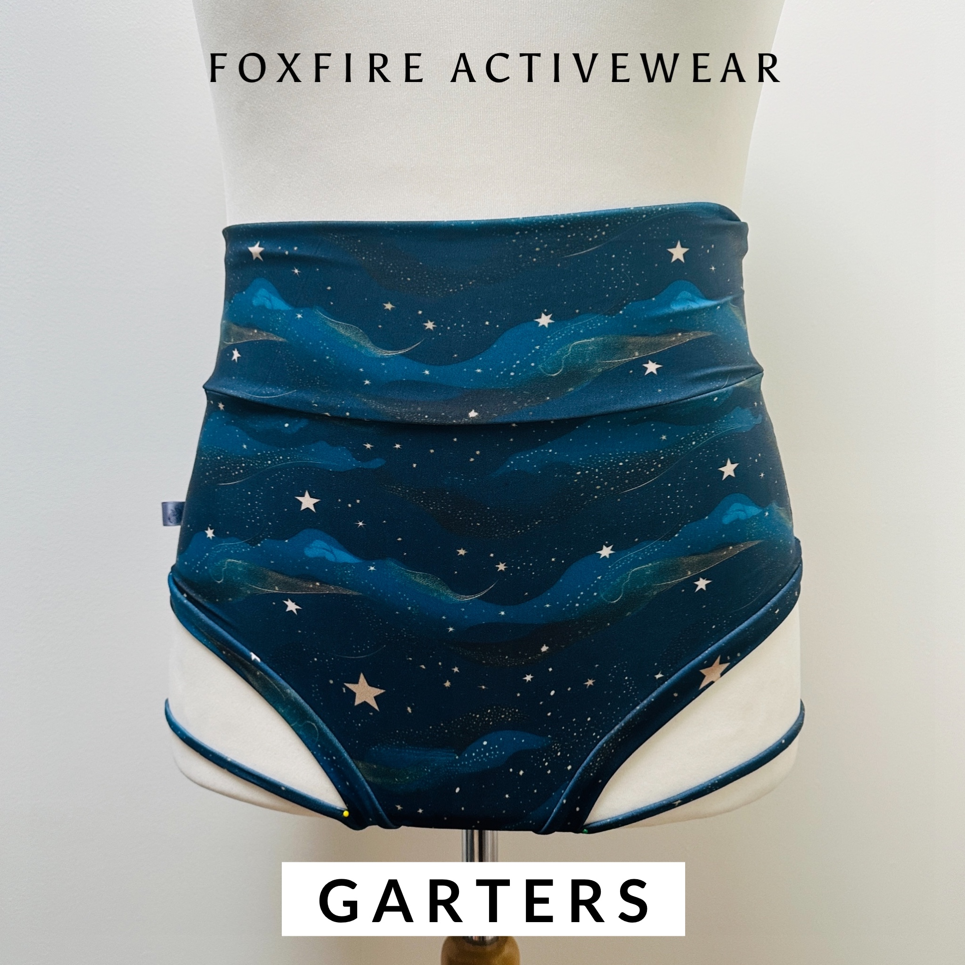

|  | **XXS** | **XS** | **S** | **M** | **L** | **XL** | **XXL** | **3XL** | **4XL** | **5XL** | **6XL** |
| --- | --- | --- | --- | --- | --- | --- | --- | --- | --- | --- | --- |
| **Waist** | 23-  26” | 26-  28” | 28-  31” | 31-  34” | 34-  36” | 36-  39” | 39-  42” | 42-  46” | 46-  50” | 50-  54” | 54-  58” |
| **Full Hip** | 30-  32” | 33-  35” | 35.5-37.5” | 38-  40” | 41-  43” | 44-  46” | 47-  50” | 51-  54” | 55-  58” | 59-  62” | 63-  66” |
| **Garter (Thigh circumference)** | 20.5” | 21” | 22” | 23” | 24.5” | 27” | 29” | 31” | 32.5” | 34” | 36” |

**Thongs**

Thongs are available in Mid or High waist. They have a band at the waist and hemmed, elasticated legs. These sit higher on the leg than the banded options.

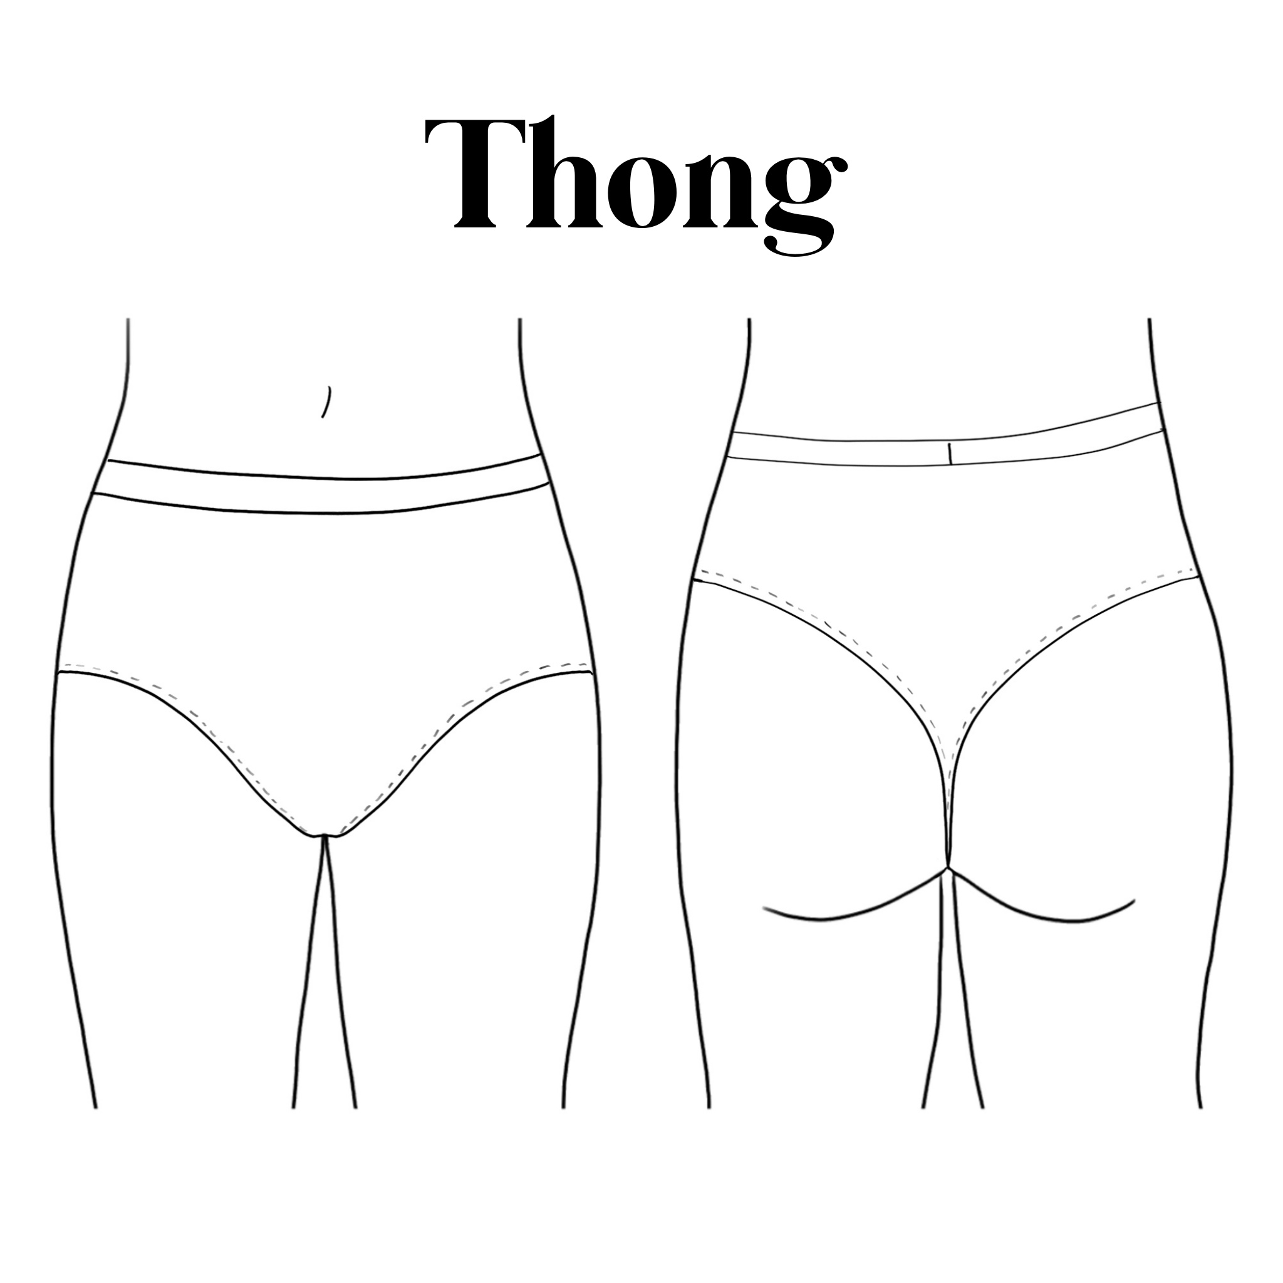

|  | **XXS** | **XS** | **S** | **M** | **L** | **XL** | **XXL** | **3XL** | **4XL** |
| --- | --- | --- | --- | --- | --- | --- | --- | --- | --- |
| **Waist** | 23.5” | 24.5” | 25-26” | 27-28” | 29-30” | 31-34” | 35-38” | 39-42” | 43-46” |
| **Hips** | 33-34.5” | 35-36” | 37-38” | 39-40” | 41-43” | 44-45” | 46-48” | 49-51” | 52-54” |

**Finley Pole Shorts**

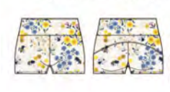

For those that prefer a slightly higher level of coverage across their upper thighs. These are perfect for pole and acro! These have an arc detail on the back to give extra shape. This style is High Waisted only but the band can be folded down to expose more skin.

|  | **XXS** | **XS** | **S** | **M** | **L** | **XL** | **XXL** | **3XL** | **4XL** | **5XL** | **6XL** | **7XL** |
| --- | --- | --- | --- | --- | --- | --- | --- | --- | --- | --- | --- | --- |
| **Waist** | 23-  24” | 25-  26” | 27-  28” | 29-  30” | 31-  33” | 34-  36” | 37-  39” | 40-  42” | 43-  46” | 47-  50” | 51-  53” | 54-  57” |
| **Full Hip** | 34-  35” | 35-  36” | 37-  38” | 39-  40” | 41-  43” | 44-  46” | 47-  49” | 50-  52” | 53-  55” | 56-  58” | 59-  61” | 62-  64” |
| **Upper**  **thigh** | 20.5” | 21” | 22” | 23” | 24.5” | 27” | 29” | 31” | 32.5” | 34” | 36” | 37.5” |

**Twist Front Crop & Cross Back Crop**

The twist front crop top is a super secure bralet with a keyhole at the front and wide racer at the back. Suitable for all fitness, swimming and aerial activities. The band can be made smaller/bigger if you are between sizes. Elasticated Underband.

The cross back crop top is suitable for light exercise and can also be used over a sports bra for extra support. Suitable for all fitness, swimming and aerial activities. The band can be made smaller/bigger if you are between sizes. Non Elasticated Underband.

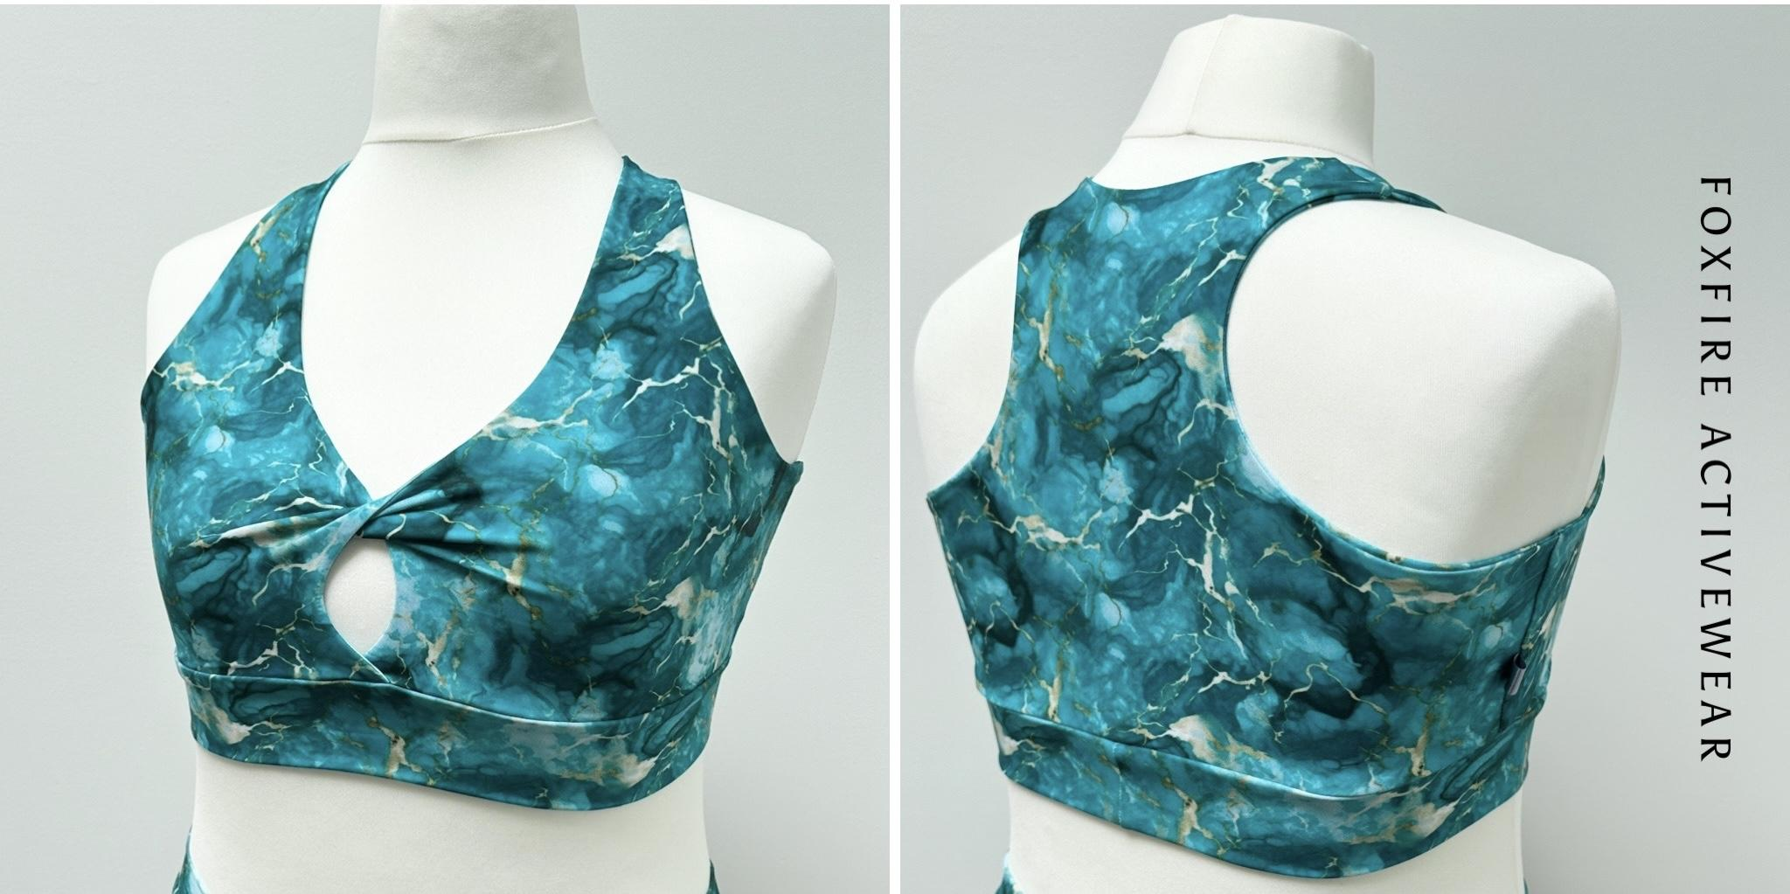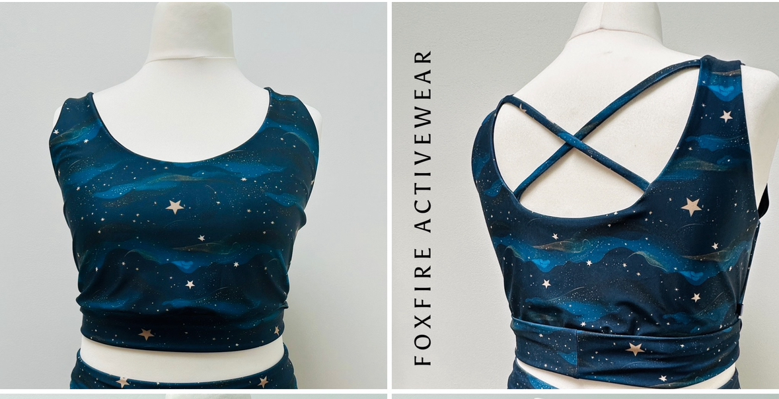

|  | **XXS** | **XS** | **S** | **M** | **L** | **XL** | **XXL** | **3XL** | **4XL** | **5XL** | **6XL** | **7XL** |
| --- | --- | --- | --- | --- | --- | --- | --- | --- | --- | --- | --- | --- |
| **UpperBust** | 31” | 32” | 33” | 34” | 35.5” | 37.5” | 40.5” | 43” | 46” | 48” | 51” | 53” |
| **Full Bust** | 30-  31” | 32-  33” | 34-  35” | 36-  37” | 38-  39” | 40-  42” | 43-  45” | 46-  48” | 49-  51” | 52-  54” | 55-  57” | 58-  60” |
| **Under Bust** | 26” | 27.5” | 29” | 30.5” | 32” | 34.5” | 37” | 40” | 43” | 46” | 49” | 52” |

**Plunge Cross Back Bra**

The plunge cross back bra is a cross over front with a cross back design. Suitable for all fitness, swimming and aerial activities as well as every day bra use. This style follows a cup size. Please use the guide below to determine your cup size as it will likely **not** reflect your usual cup size. Band sizes can be made bigger or smaller on request. Elasticated Underband.

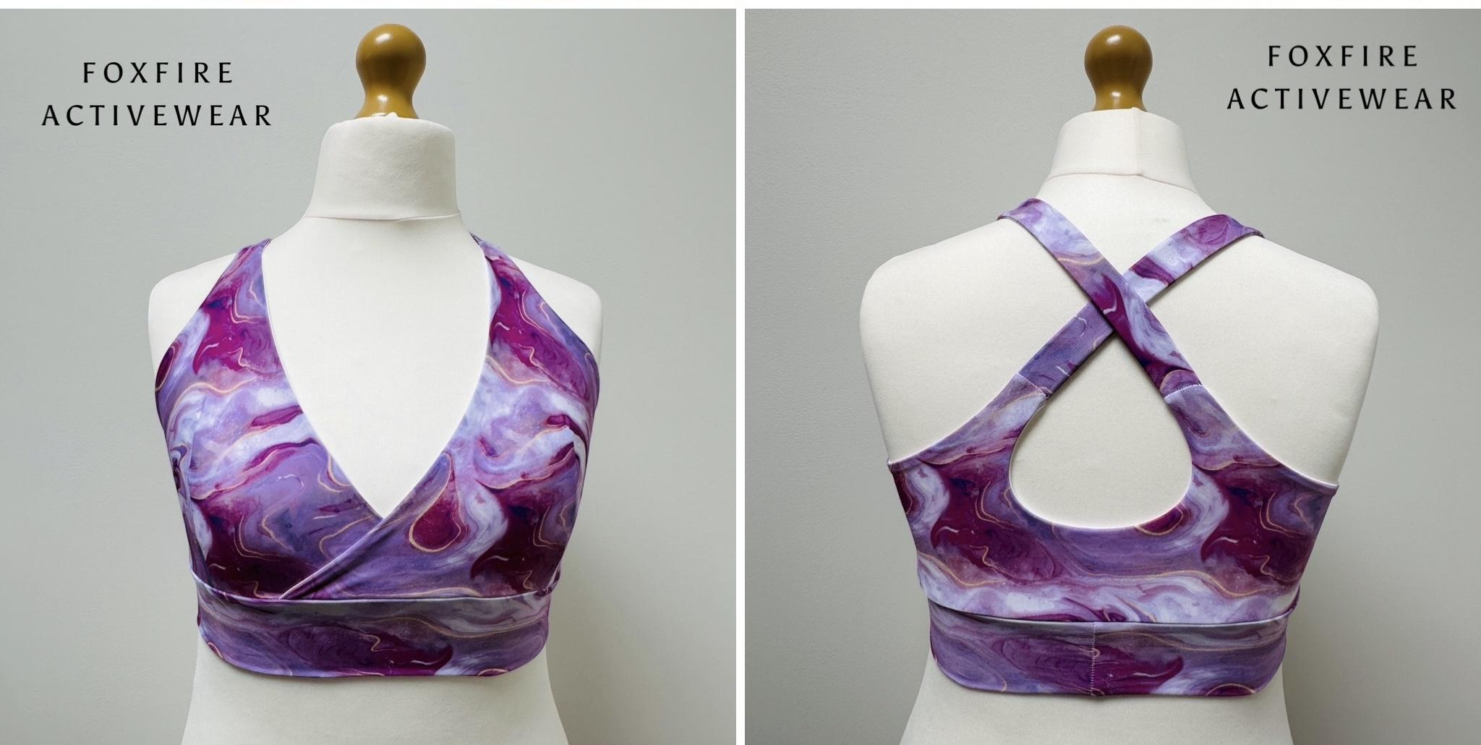

|  | **XXS** | **XS** | **S** | **M** | **L** | **XL** | **XXL** | **3XL** | **4XL** | **5XL** |
| --- | --- | --- | --- | --- | --- | --- | --- | --- | --- | --- |
| **Upper**  **Bust** | 28-30” | 30-32” | 32-34” | 34-36” | 36-38” | 38-40” | 40-43” | 43-46” | 46-49” | 49-52” |
| **Under Bust** | 26” | 27.5” | 29” | 30.5” | 32” | 34.5” | 37” | 40” | 43” | 46” |

Find the ‘best fit’ for the size selection but use accurate measurements to find the cup size. To find the cup size, take your **Full Bust** and **Upper Bust** measurement and find the **difference**.

| **Difference** | 1” | 2” | 3” | 4” | 5” | 6” | 7” | 8” |
| --- | --- | --- | --- | --- | --- | --- | --- | --- |
| **Cup Size** | A | B | C | D | E | F | G | H |

**\*NEW SIZING* Braided Crop**

The braided crop top is a comfy scoop neck bralet with a braided feature at the back. Suitable for all fitness, swimming and aerial activities. This style follows a cup size. Please use the guide below to determine your size by comparing your full bust to the upper bust measurement. This will give you your cup size. Band sizes can be made bigger or smaller on request. Elasticated Underband.

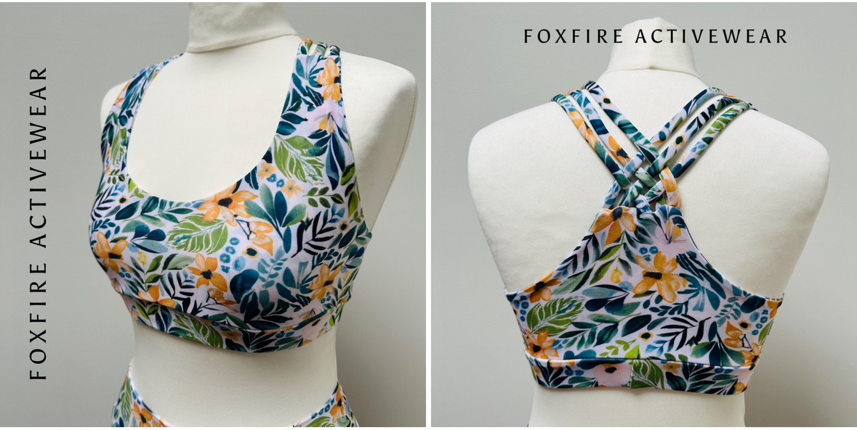

|  | **XXS** | **XS** | **S** | **M** | **L** | **XL** | **XXL** | **3XL** | **4XL** | **5XL** | **6XL** |
| --- | --- | --- | --- | --- | --- | --- | --- | --- | --- | --- | --- |
| **Upper**  **Bust** | 29” | 31” | 32.5” | 34” | 35.5” | 37” | 38.5” | 40” | 42.5” | 44.5” | 47” |
| **Full Bust**  **(A-C Cup)** | 29” -  32” | 31” -  35” | 32.5”-  35.5” | 34” -  37” | 35.5”-  38.5” | 37”-  41” | 38.5” -  41.5” | 40” -  43” | 41.5” -  44.5” | 43” -  46” | 44.5” -  47.5” |
| **Full Bust**  **(D-DDD Cup)** | 33” - 35” | 36” -  38” | 36.5” -  38.5” | 38” -  40” | 39.5” -  41.5” | 41” -  43” | 42.5” -  45.5” | 44” -  46.5” | 45.5” - 48” | 47” -  49” | 48.5” -  51” |
| **Under Bust** | 26” | 27.5” | 29” | 30.5” | 32” | 34.5” | 37 | 37” | 40” | 43” | 45” |

With our braided crop top, there are two cup choices. A-C (Standard Bust) or D-DDD (Full Bust). To find your size, first measure your **upper bust** measurement. Then, check your **full bust** measurement and look at the two boxes below your upper bust measurement to check if you need the A-C or D-DDD cup. If your underbust measurement doesn’t match these, please do not worry as we can put a custom band on for you.

**IMPORTANT**

*It’s extremely important that you measure carefully as this can affect how your item fits when it arrives. Items that are bespoke to sizing (Custom band sizes or portions of the item’s sizing being changed) are non refundable but can be altered for a small fee. Items made from standard sizing can be returned within 14 days of receiving the item in it’s original, unworn condition.*

*ALTERATIONS COST £5 PER ITEM PLUS POSTAGE AND THE CUSTOMER IS LIABLE TO PAY FOR THE POSTAGE BACK TO US.*